**WORKING INSTRUCTIONS**

|  |  |
| --- | --- |
| **Doc Nr.:** | **NCT LAB** |
| **Version:** | **Continental TCI, Bangalore** |
| **Impl. Date:** | **Model: Keysight Oscilloscope MSOX3054A** |

|  |
| --- |
| **Safety Instructions/ ESD/3S** |
| 1. **Always follow working instruction** 2. **Clean the machine table before usage and clean the equipment if any dirt and dust found.** 3. **After completing the work do not keep the fixtures, test components on the machine table.**  |  |  |  | | --- | --- | --- | | **S1 (Seiri)** | **S2 (Seiton)** | **S3 (Seisou)** | | **Prepare needed tools** | **Keep everything tidy** | **Always keep clean** | |

|  |
| --- |
| **Unusual Case** |
| **If the equipment functions abnormally, e.g. strange sounds, warning signal or something looks unusual:**   |  | | --- | | **Stop machine – Inform - Waiting** |   **Stop the machine**  **Inform to the lab incharge**  **Wait for the decision** |

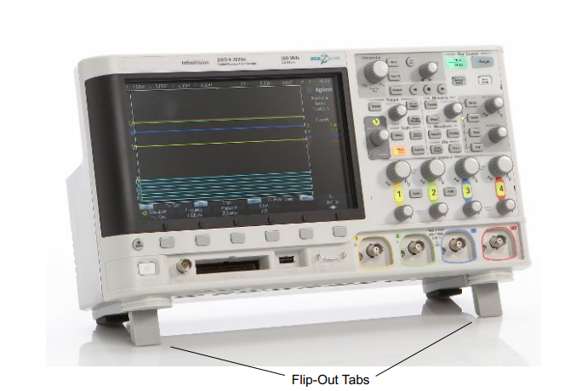

**Safety labels on products:**

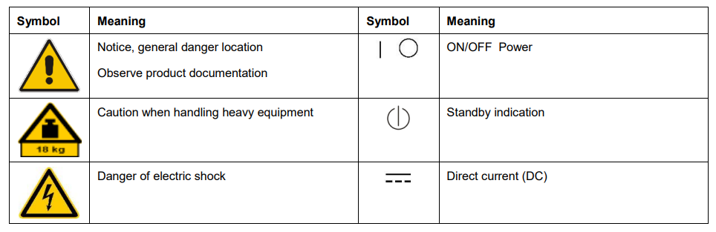

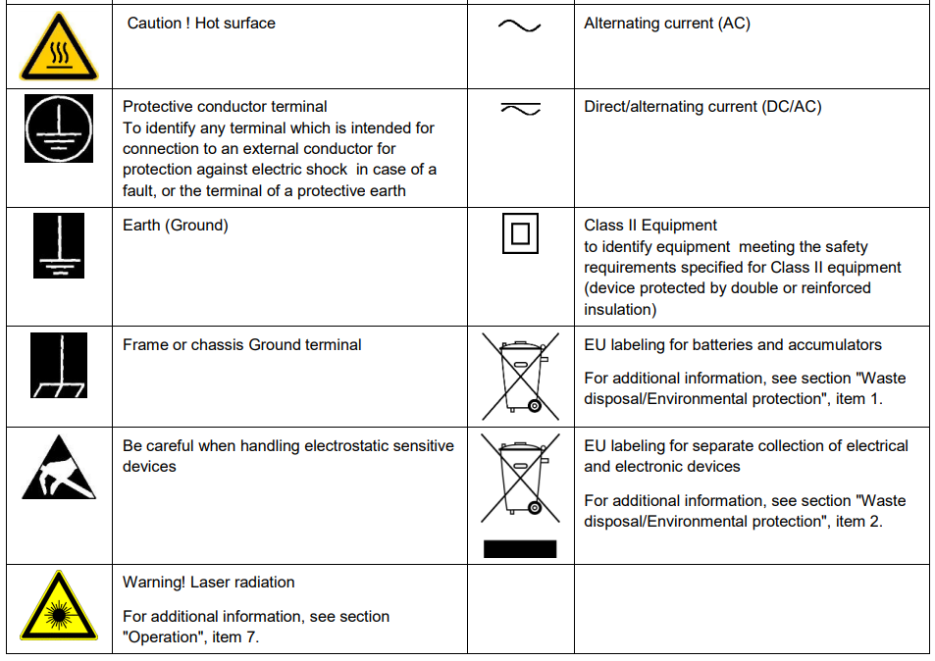

**Risk of instrument damage during operation:**

An unsuitable operating site or test setup can damage the instrument and connected devices. Ensure the following operating conditions before you switch on the instrument:

* Make sure that the nominal voltage setting on the product matches the nominal voltage of the AC supply network.
* Never use the instrument in dusty or damp conditions, in an explosion hazard area, or near aggressive chemicals. The ambient temperature and humidity must not exceed the ranges specified for the equipment.
* The instrument should be dry and shows no sign of condensation.
* The instrument can only be operated with a properly grounded safety socket outlet.
* Never use a cheater plug or other means to defeat or disconnect the protective ground lead.
* Check the power cable for damage and replace it if necessary. The power cord must be plugged in before signal circuits are connected.
* Before each measurement, check the instrument for proper operation using a known signal source or sample.
* Signal levels at the input connectors are all within the specified ranges.
* Signal outputs are correctly connected and are not overloaded.

**Power-On the Oscilloscope:**

1. Power Requirements Line voltage, frequency, and power:

• ~Line 100-120 Vac, 50/60/400 Hz

• 100-240 Vac, 50/60 Hz

• 100 W max

|  |
| --- |
| **CAUTION**   * This instrument has auto-ranging line voltage input. Be sure the supply voltage is within the specified range and voltage fluctuations do not to exceed 10 percent of the nominal supply voltage. |

**Ventilation Requirements:**

The air intake and exhaust areas must be free from obstructions. Unrestricted air flow is required for proper cooling. Always ensure that the air intake and exhaust areas are free from obstructions. The fan draws air in from the left side and bottom of the oscilloscope and pushes it out behind the oscilloscope.

|  |
| --- |
| **CAUTION:**   * Use only the power cord that came with the oscilloscope The power cord provided is matched to the country of origin of the order. |

WARNING

* Always use a grounded power cord. Do not defeat the power cord ground.
* Do not negate the protective action of the ground connection to the oscilloscope. The oscilloscope must remain grounded through its power cord. Defeating the ground creates an electric shock hazard.

**Getting Started:**

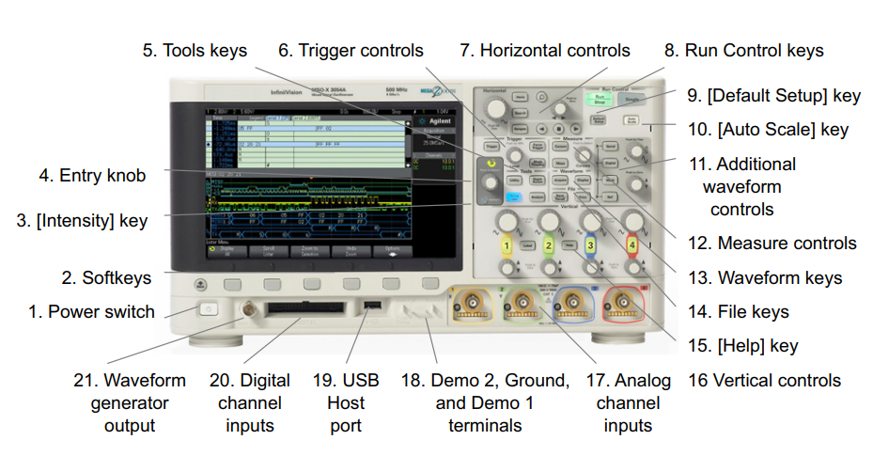

|  |  |  |
| --- | --- | --- |
| 1. | **Power switch** | Press once to switch power on; press again to switch power off |
| 2. | **Soft keys** | The functions of these keys change based upon the menus shown on the display directly above the keys. The Back/Up key moves up in the softkey menu hierarchy. At the top of the hierarchy, the Back/Up key turns the menus off, and oscilloscope information is shown instead. |
| 3. | **Intensity keys** | Press the key to illuminate it. When illuminated, turn the Entry knob to adjust waveform intensity. You can vary the intensity control to bring out signal detail, much like an analog oscilloscope. Digital channel waveform intensity is not adjustable. |
| 4. | **Entry knob** | The Entry knob is used to select items from menus and to change values. The function of the Entry knob changes based upon the current menu and softkey selections. Note that the curved arrow symbol above the entry knob illuminates whenever the entry knob can be used to select a value. Also, note that when the Entry knob symbol appears on a softkey, you can use the Entry knob, to select values. Often, rotating the Entry knob is enough to make a selection. Sometimes, you can push the Entry knob to enable or disable a selection. Pushing the Entry knob also makes popup menus disappear. |
| 5. | **Tool Keys** | The Tools keys consist of:  • [Utility] key — Press this key to access the Utility Menu, which lets you configure the oscilloscope's I/O settings, use the file explorer, set preferences, access the service menu, and choose other options  • [Quick Action] key — Press this key to perform the selected quick action: measure all snapshot, print, save, recall, freeze display. and more  • [Analyze] key — Press this key to access analysis features like trigger level setting, measurement threshold setting, Video trigger automatic set up and display, mask testing |
| 6. | **Trigger Controls** | These controls determine how the oscilloscope triggers to capture data. |
| 7. | **Horizontal controls** | The Horizontal controls consist of:  • Horizontal scale knob — Turn the knob in the Horizontal section that is marked to adjust the time/div (sweep speed) setting. The symbols under the knob indicate that this control has the effect of spreading out or zooming in on the waveform using the horizontal scale.  • Horizontal position knob — Turn the knob marked to pan through the waveform data horizontally. You can see the captured waveform before the trigger (turn the knob clockwise) or after the trigger (turn the knob counterclockwise). If you pan through the waveform when the oscilloscope is stopped (not in Run mode) then you are looking at the waveform data from the last acquisition taken.  • [Horiz] key — Press this key to open the Horizontal Menu where you can select XY and Roll modes, enable or disable Zoom, enable or disable horizontal time/division fine adjustment, and select the trigger time reference point.  • Zoom key — Press the zoom key to split the oscilloscope display into Normal and Zoom sections without opening the Horizontal Menu.  • [Search] key — Lets you search for events in the acquired data.  • [Navigate] keys — Press this key to navigate through captured data (Time), search events, or segmented memory acquisitions |
| 8. | **Run Control Keys** | When the [Run/Stop] key is green, the oscilloscope is running, that is, acquiring data when trigger conditions are met.  To stop acquiring data, press [Run/Stop]. When the [Run/Stop] key is red, data acquisition is stopped. To start acquiring data, press [Run/Stop].  To capture and display a single acquisition (whether the oscilloscope is running or stopped), press [Single]. The [Single] key is yellow until the oscilloscope triggers. |
| 9. | **[Default Setup] key** | Press this key to restore the oscilloscope's default settings |
| 10. | **[Auto Scale] key** | When you press the [AutoScale] key, the oscilloscope will quickly determine which channels have activity, and it will turn these channels on and scale them to display the input signals. |
| 11. | **Additional waveform controls** | The additional waveform controls consist of:  • [Math] key — provides access to math (add, subtract, etc.) waveform functions  • [Ref] key — provides access to reference waveform functions. Reference waveforms are saved waveforms that can be displayed and compared against other analog channel or math waveforms  • [Digital] key — Press this key to turn the digital channels on or off (the arrow to the left will illuminate).  When the arrow to the left of the [Digital] key is illuminated, the upper multiplexed knob selects (and highlights in red) individual digital channels, and the lower multiplexed knob positions the selected digital channel. If a trace is repositioned over an existing trace the indicator at the left edge of the trace will change from Dnn designation (where nn is a one or two digit channel number from 0 to 15) to D*. The "*" indicates that two channels are overlaid. You can rotate the upper knob to select an overlaid channel, then rotate the lower knob to position it just as you would any other channel.  • [Serial] key — This key is used to enable serial decode. The multiplexed scale and position knobs are not used with serial decode. For more information on serial decode  Multiplexed scale knob — This scale knob is used with Math, Ref, or Digital waveforms, whichever has the illuminated arrow to the left. For math and reference waveforms, the scale knob acts like an analog channel vertical scale knob.  • Multiplexed position knob — This position knob is used with Math, Ref, or Digital waveforms, whichever has the illuminated arrow to the left. For math and reference waveforms, the position knob acts like an analog channel vertical position knob. |
| 12. | **Measure controls** | The measure controls consist of:  • Cursors knob — Push this knob select cursors from a popup menu. Then, after the popup menu closes (either by timeout or by pushing the knob again), rotate the knob to adjust the selected cursor position.  • [Cursors] key — Press this key to open a menu that lets you select the cursors mode and source.  • [Meas] key — Press this key to access a set of predefined measurements |
| 13. | **Waveform keys** | The [Acquire] key lets you select Normal, Peak Detect, Averaging, or High Resolution acquisition modes and use segmented memory  The [Display] key lets you access the menu where you can enable persistence clear the display, and adjust the display grid intensity |
| 14. | **File keys** | Press the [Save/Recall] key to save or recall a waveform or setup.  The [Print] key opens the Print Configuration Menu so you can print the displayed waveforms. |
| 15. | **[Help] key** | Opens the Help Menu where you can display overview help topics and select the Language. |
| 16. | **Vertical controls** | The Vertical controls consist of:  • Analog channel on/off keys — Use these keys to switch a channel on or off, or to access a channel's menu in the softkeys. There is one channel on/off key for each analog channel.  • Vertical scale knob — There are knobs marked for each channel. Use these knobs to change the vertical sensitivity (gain) of each analog channel.  • Vertical position knobs — Use these knobs to change a channel's vertical position on the display. There is one Vertical Position control for each analog channel.  • [Label] key — Press this key to access the Label Menu, which lets you enter labels to identify each trace on the oscilloscope display. |
| 17. | **Analog channel inputs** | Attach oscilloscope probes or BNC cables to these BNC connectors. With the InfiniiVision 3000 X-Series oscilloscopes, you can set the input impedance of the analog channels to either 50 Ω or 1 MΩ.  The InfiniiVision 3000 X-Series oscilloscopes also provide the AutoProbe interface. The AutoProbe interface uses a series of contacts directly below the channel's BNC connector to transfer information between the oscilloscope and the probe. When you connect a compatible probe to the oscilloscope, the AutoProbe interface determines the type of probe and sets the oscilloscope's parameters (units, offset, attenuation, coupling, and impedance) accordingly |
| 18. | **Demo 2, Ground, and Demo 1 terminals** | • Demo 2 terminal — This terminal outputs the Probe Comp signal which helps you match a probe's input capacitance to the oscilloscope channel to which it is connected  • Ground terminal — Use the ground terminal for oscilloscope probes connected to the Demo 1 or Demo 2 terminals.  • Demo 1 terminal — With certain licensed features, the oscilloscope can output demo or training signals on this terminal. |
| 19. | **USB Host port** | This port is for connecting USB mass storage devices or printers to the oscilloscope. Connect a USB compliant mass storage device (flash drive, disk drive, etc.) to save or recall oscilloscope setup files and reference waveforms or to save data and screen images  You can also use the USB port to update the oscilloscope's system software when updates are available. You do not need to take special precautions before removing the USB mass storage device from the oscilloscope (you do not need to "eject" it). Simply unplug the USB mass storage device from the oscilloscope when the file operation is complete |
| 20. | **Digital channel inputs** | Connect the digital probe cable to this connector (MSO models only). |
| 21. | **Waveform generator output** | Outputs sine, square, ramp, pulse, DC, or noise on the Gen Out BNC. Press the [Wave Gen] key to set up the waveform generator. |

**Front Panel Overlays for Different Languages:**

1. Front panel overlays, which have translations for the English front panel keys and label text, are available in 10 languages. The appropriate overlay is included when the localization option is chosen at time of purchase
2. To install a front panel overlay:
   1. Gently pull on the front panel knobs to remove them.
   2. Insert the overlay's side tabs into the slots on the front panel
   3. Reinstall the front panel knobs.

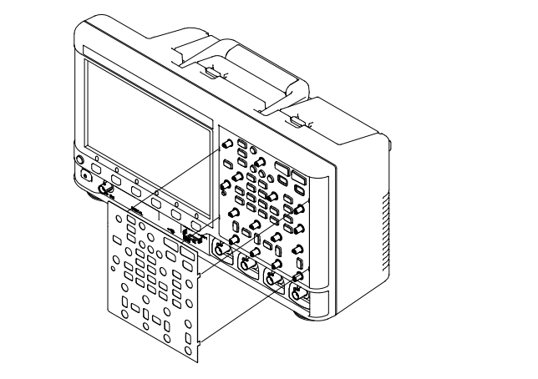

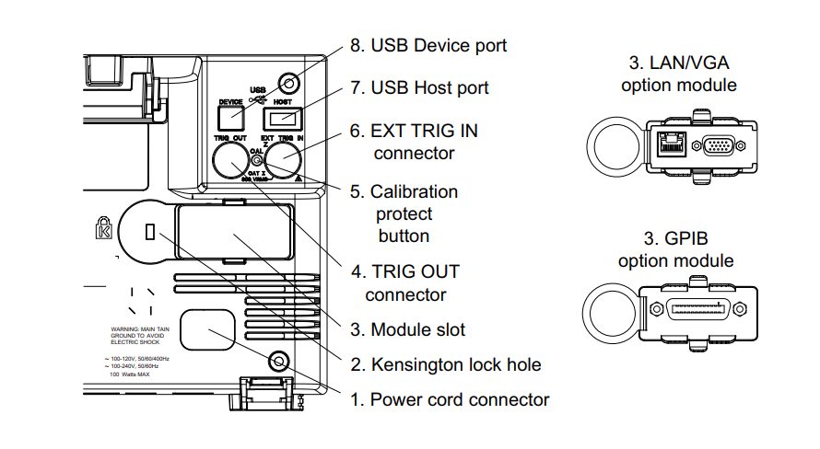

|  |  |  |
| --- | --- | --- |
| **1.** | **Power cord connector** | Attach the power cord here |
| **2.** | **Kensington lock hole** | This is where you can attach a Kensington lock for securing the instrument. |
| **3.** | **Module slot** | A DSOXLAN LAN/VGA module may be ordered and installed separately.  • LAN port — lets you communicate with the oscilloscope and use the Remote Front Panel feature using the LAN port  • VGA video output — lets you connect an external monitor or projector to provide a larger display or to provide a display at a viewing position away from the oscilloscope. The oscilloscope's built-in display remains on even when an external display is connected. The video output connector is always active. For optimal video quality and performance, we recommend you use a shielded video cable with ferrite cores. |
| **4.** | **TRIG OUT connector** | Trigger output BNC connector |
| **5.** | **Calibration protect button** | User Cal performs an internal self-alignment routine to optimize the signal path in the oscilloscope. The routine uses internally generated signals to optimize circuits that affect channel sensitivity, offset, and trigger parameters. |
| **6** | **EXT TRIG IN connector** | External trigger input BNC connector. |
| **7.** | **USB Host port** | This port functions identically to the USB host port on the front panel. USB Host Port is used for saving data from the oscilloscope and loading software updates. See also USB Host port |
| **8.** | **USB Device port** | This port is for connecting the oscilloscope to a host PC. You can issue remote commands from a host PC to the oscilloscope via the USB device port |

**The Oscilloscope Display**

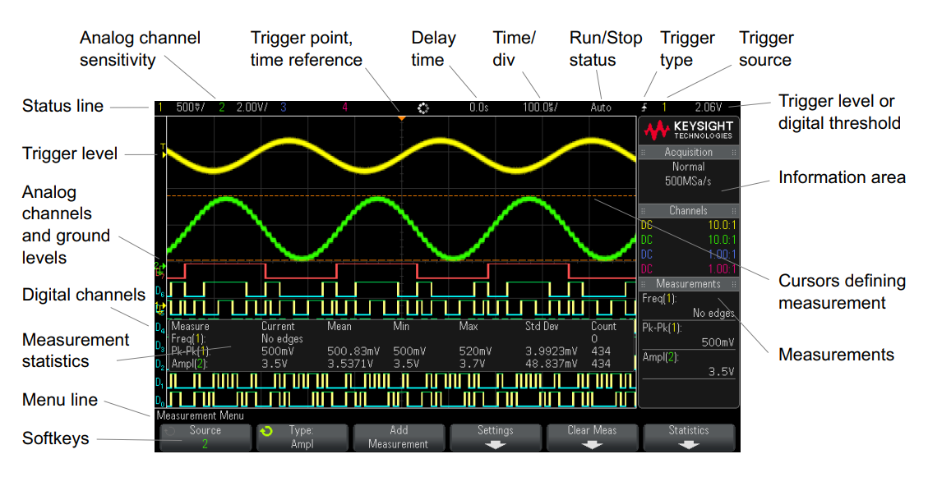

|  |  |
| --- | --- |
| **Status line** | The top line of the display contains vertical, horizontal, and trigger setup information |
| **Display area** | Signal detail is displayed using 256 levels of intensity. |
| **Information area** | The information area normally contains acquisition, analog channel, automatic measurement, and cursor results. |
| **Menu line** | This line normally contains menu name or other information associated with the selected menu. |
| **Softkey labels** | These labels describe softkey functions. Typically, softkeys let you set up additional parameters for the selected mode or menu. Pressing the Back/Up key at the top of the menu hierarchy turns off softkey labels and displays additional status information describing channel offset and other configuration parameters |